**Project Design Phase-II**

**Data Flow Diagram & User Stories**

|  |  |
| --- | --- |
| Date | 03 October 2022 |
| Team ID | PNT2022TMIDxxxxxx |
| Project Name | An Android Application for Keeping Up with the Latest Headlines |
| Maximum Marks | 4 Marks |

Team Members

Team Leader : Arya Suhas Kharote

Team member : TK Prem Chand

Team member : Sai Teja Reddy Muga

Team member : Mathuku Balaji Reddy

**Data flow diagram**

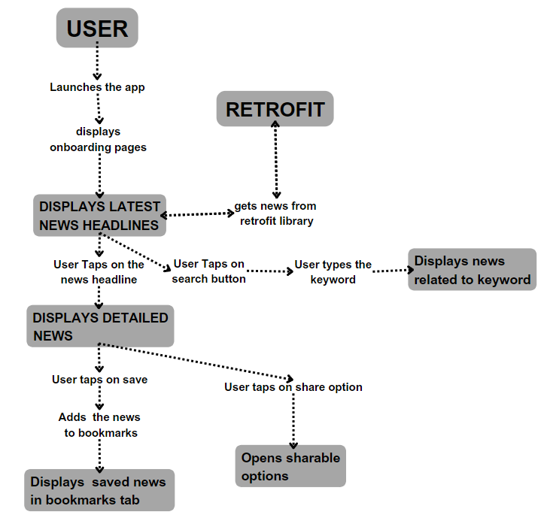

Use the below template to list all the user stories for the product.

| **User Type** | **Functional Requirement (Epic)** | **User Story Number** | **User Story / Task** | **Acceptance criteria** | **Priority** | **Release** |
| --- | --- | --- | --- | --- | --- | --- |
| Customer (Mobile user) | Launching the app and navigating | USN-1 | As a user, I can launch the app and look at news headlines | I can launch the app and look at headlines | High | Sprint-1 |
|  |  | USN-2 | As a user, I can view detailed news | I can view detailed news on tapping the headlines | High | Sprint-1 |
|  |  | USN-3 | As a user, I can save and add news to bookmarks | I can save news to bookmarks | medium | Sprint-2 |
|  |  | USN-4 | As a user, I can share news | I can share news | low | Sprint-2 |
|  |  | USN-5 | As a user, I can search for news | I can search news | medium | Sprint-1 |
| Customer (Web user) |  |  |  |  |  |  |
| Customer Care Executive |  |  |  |  |  |  |
| Administrator |  |  |  |  |  |  |
|  |  |  |  |  |  |  |
|  |  |  |  |  |  |  |
|  |  |  |  |  |  |  |